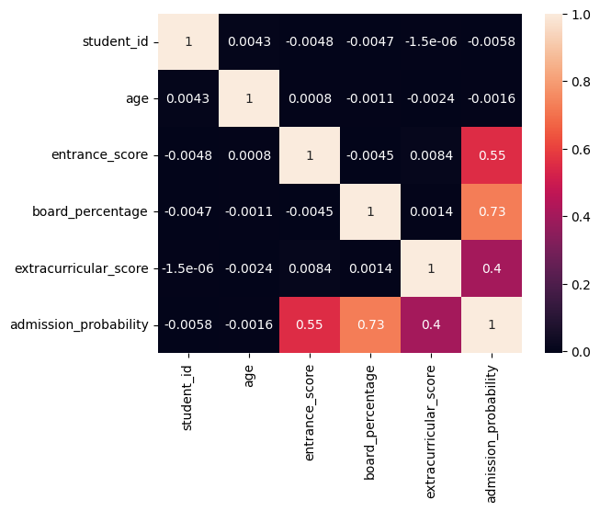

This graph is a correlation heatmap. It shows how strongly each pair of variables in your dataset is related to each other, especially how they relate to admission_probability.

What this graph represents
- Each row and column is a variable:
  - student_id
  - age
  - entrance_score
  - board_percentage
  - extracurricular_score
  - admission_probability
- Each cell value is a correlation coefficient (Pearson correlation):
  - Range: -1 to +1
    - +1 → perfect positive relationship
    - 0 → no relationship
    - -1 → perfect negative relationship
- Color meaning:
  - Light / warm colors (orange–red) → stronger positive correlation
  - Dark colors → weak or no correlation
- The diagonal values are 1 because each variable is perfectly correlated with itself.

🔹 Line-by-line (variable-by-variable) explanation
1️⃣ student_id
- Correlation with all variables ≈ 0
- This means:
  - student_id has no meaningful relationship with admission probability or any feature
  - It is just an identifier
- ✅ Correct decision to exclude it from modeling

2️⃣ age
- Correlation with admission_probability = -0.0016
- This is almost zero
📌 Interpretation:
- Age does not affect admission probability
- Older or younger students have nearly the same chance

3️⃣ entrance_score
- Correlation with admission_probability = 0.55
📌 Interpretation:
- Moderate positive correlation
- As entrance exam score increases, admission probability significantly increases
- This is an important predictive feature

4️⃣ board_percentage
- Correlation with admission_probability = 0.73
📌 Interpretation:
- Strong positive correlation
- Students with higher board percentages have a much higher chance of admission
- This is the most influential academic feature in the dataset

5️⃣ extracurricular_score
- Correlation with admission_probability = 0.40
📌 Interpretation:
- Moderate positive correlation
- Extracurricular activities improve admission chances
- Less influential than academics, but still important

6️⃣ Relationship between predictors
- entrance_score vs board_percentage ≈ -0.0045
- board_percentage vs extracurricular_score ≈ 0.0014
📌 Interpretation:
- Predictors are not strongly correlated with each other
- This is good because:
  - No multicollinearity
  - Model can learn independent effects

🔹 Key insights from the graph
✔ Academic performance matters most
- Board percentage is the strongest factor
- Entrance score is second strongest
✔ Extracurricular activities help, but less than academics
✔ Age and student ID are irrelevant
- Should not be used for prediction
✔ Dataset is well-structured
- Low redundancy between features
- Ideal for machine learning models

🔹 One-line summary (for exams / viva)
“The heatmap shows that admission probability is strongly influenced by board percentage and entrance score, moderately influenced by extracurricular activities, and almost independent of age and student ID.”

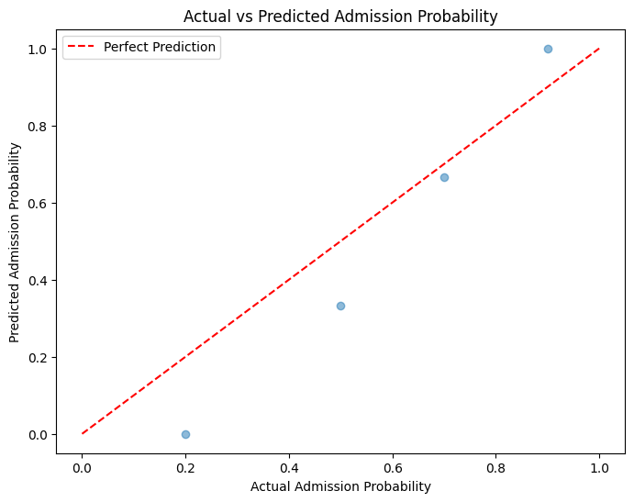

This scatter plot titled "Actual vs Predicted Admission Probability" is a diagnostic tool used to evaluate the performance of a predictive model—likely one estimating the probability of admission to a program or institution. Here's how to interpret it:
📊 Graph Components
- X-axis (Actual Admission Probability): Represents the true probability of admission, possibly derived from historical data or expert judgment.
- Y-axis (Predicted Admission Probability): Shows the probabilities predicted by the model for the same cases.
- Light Blue Dots: Each dot corresponds to a data point—an individual applicant or case. Its position reflects how close the model's prediction was to the actual outcome.
- Red Dashed Line ("Perfect Prediction"): This diagonal line (y = x) represents ideal predictions—where the predicted probability exactly matches the actual probability.

🔍 What the Graph Reveals
- Dots on the red line: Perfect predictions—model output matches reality.
- Dots near the line: Good predictions—model is reasonably accurate.
- Dots far from the line: Poor predictions—model deviates significantly from actual outcomes.
📈 Model Evaluation Insights
- If most points cluster tightly around the red line, the model is performing well.
- If points are scattered widely, especially far from the line, the model may need improvement.
- With only four data points shown, this is likely a small test or illustrative example, not a full validation.

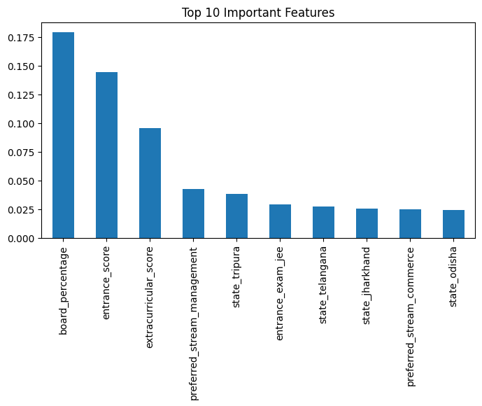
This bar chart titled "Top 10 Important Features" highlights the most influential variables used in a predictive model—likely one estimating admission probability or a similar outcome. Here's a breakdown of what it tells us:
📊 Graph Components
- X-axis (Features): Lists the top 10 features used in the model.
- Y-axis (Importance Values): Indicates how much each feature contributes to the model's predictions. Higher values mean greater influence.
🔝 Top Features and Their Impact
Feature | Importance (Approx.) | Interpretation
board_percentage | ~0.18 | Academic performance in school is the strongest predictor.
entrance_score | ~0.14 | Entrance exam results are also highly influential.
extracurricular_score | ~0.095 | Non-academic achievements play a notable role.
preferred_stream_management | ~0.04 | Preference for management stream affects outcomes.
state_tripura | ~0.038 | Geographic location (Tripura) has some influence.
entrance_exam_jee | ~0.03 | Taking the JEE exam contributes to prediction.
state_telangana | ~0.028 | Telangana as a state factor has minor impact.
state_jharkhand | ~0.027 | Jharkhand’s influence is similar to Telangana.
preferred_stream_commerce | ~0.026 | Commerce stream preference has a small effect.
state_odisha | ~0.025 | Odisha’s influence is the least among the top 10.
🔍 Insights
- Academic metrics dominate: Board percentage and entrance scores are the most critical.
- Geographic and preference factors matter: State and stream choices have moderate to low impact.
- Model transparency: This chart helps stakeholders understand which variables drive predictions, aiding in fairness and interpretability.

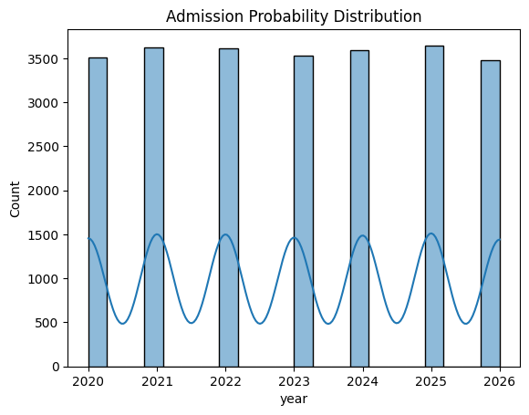
This graph titled "Admission Probability Distribution" combines a bar chart and a sinusoidal line to show two different aspects of admission data from 2020 to 2026. Here's a breakdown of what it reveals:
📊 Graph Components
- X-axis (Year): Covers the range from 2020 to 2026.
- Y-axis (Count): Measures the number of instances, ranging from 0 to 4000.
- Light Blue Bars: Represent the total count of admission-related data points per year.
- Sinusoidal Line: Shows a periodic fluctuation in admission probability across the years.
🔍 Interpretation
🟦 Bar Chart (Count per Year)
- The bars are consistently close to 3600 each year.
- This suggests that the volume of applicants or admissions data remains stable annually.
- It provides a baseline for how many cases the model or analysis is working with.
🔴 Sinusoidal Line (Admission Probability Trend)
- The line fluctuates between ~500 and ~1500, forming a wave-like pattern.
- This indicates seasonal or cyclical variation in admission probabilities.
- Possible causes could include:
- Changes in admission criteria or policies.
- Varying applicant quality or competitiveness.
- External factors like exam difficulty or socio-economic trends.
📈 Insights
- Stable data volume: The model has a consistent dataset size each year, which is good for reliability.
- Dynamic probability trends: Admission likelihood varies year to year, which may require adaptive modeling.
- Combined visualization: Using both bars and a line helps compare static counts with dynamic probabilities.

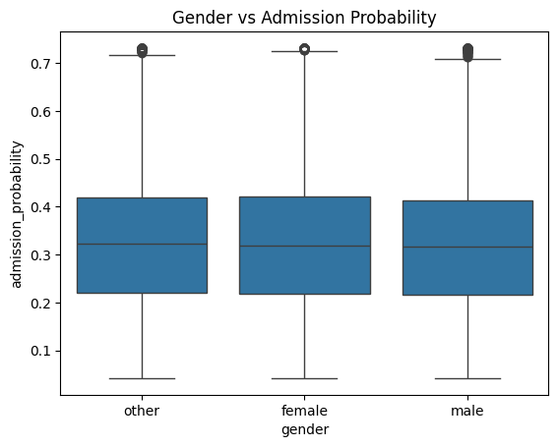

This box plot titled "Gender vs Admission Probability" is designed to compare how admission probabilities vary across different gender categories. Here's a detailed breakdown:
📊 Graph Components
- X-axis (Gender): Includes three categories — male, female, and other.
- Y-axis (Admission Probability): Represents the predicted or actual probability of admission, ranging from 0 to 1.
- Box Plot Elements:
- Median Line: The horizontal line inside each box shows the median admission probability.

• Box (Interquartile Range): Captures the middle 50% of data (from 25th to 75th percentile).
- Whiskers: Extend to show the range of non-outlier values.
- Dots Outside Whiskers: Represent outliers — unusually high or low values.
🔍 Interpretation
- Similar Medians (~0.3): All three gender groups have nearly the same median admission probability, suggesting no strong central tendency difference.
- Spread and Outliers:
- Each group shows a similar interquartile range, indicating comparable variability.
- A few outliers above 0.7 suggest that some individuals—regardless of gender—have notably high admission probabilities.
📈 Insights
- No Clear Bias: The similarity in medians and spread implies that gender may not be a significant factor in admission probability.
- Fairness Check: This visualization supports the idea that the model treats gender groups equitably, though statistical tests would be needed to confirm.
- Inclusivity: Including the "other" category reflects a thoughtful approach to gender diversity in the analysis.

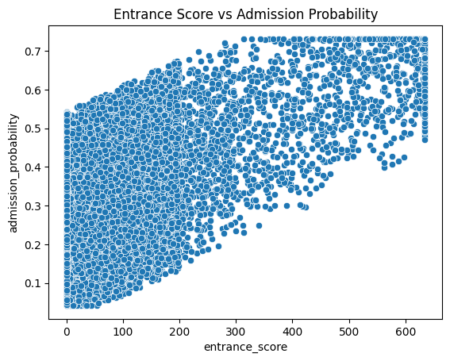

This scatter plot titled "Entrance Score vs Admission Probability" illustrates the relationship between applicants' entrance exam scores and their likelihood of admission. Here's a detailed breakdown:
📊 Graph Components
- X-axis (Entrance Score): Ranges from 0 to 600, representing the score achieved in an entrance exam.
- Y-axis (Admission Probability): Ranges from 0.1 to 0.7, indicating the predicted probability of admission.
- Data Points: Each dot represents an individual applicant, showing their entrance score and corresponding admission probability.
🔍 Interpretation
- Upward Trend: There's a clear positive correlation—as entrance scores increase, admission probability tends to rise.
- Dense Distribution: The plot is densely populated, suggesting a large sample size and consistent modeling.
- Score Thresholds:
- Scores below ~200 tend to have lower admission probabilities (closer to 0.1–0.3).
- Scores above ~400 are more likely to have higher probabilities (closer to 0.5–0.7).
📈 Insights
- Entrance Score is a Key Predictor: The upward trend confirms that entrance scores significantly influence admission chances.
- Model Behavior: The smooth progression suggests the model handles score-based predictions consistently.
- Strategic Use: Applicants can use this insight to estimate their chances and institutions can refine admission criteria.

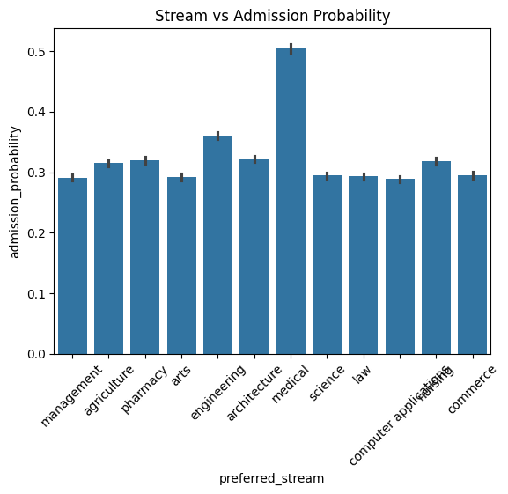

This bar chart titled "Stream vs Admission Probability" compares how likely students are to be admitted based on their preferred academic stream. Here's a detailed breakdown:
📊 Graph Components
- X-axis (Preferred Stream): Lists academic streams such as management, agriculture, pharmacy, arts, engineering, architecture, medical, science, law, computer applications, fashion, and commerce.
- Y-axis (Admission Probability): Measures the likelihood of admission, ranging from 0.0 to 0.5.
- Bars with Error Lines: Each bar shows the average admission probability for a stream, and the error bars indicate variability or uncertainty in those estimates.

🔍 Interpretation
- Medical Stream Leads: The medical stream has the highest admission probability, slightly above 0.5, suggesting strong applicant profiles or favorable admission criteria.
- Most Streams Clustered Around 0.3–0.35: Streams like engineering, science, commerce, and management show moderate admission probabilities.
- Lower Probability Streams: Streams such as fashion, arts, and architecture tend to have slightly lower probabilities, possibly due to competitive selection or fewer seats.

📈 Insights
- Stream Choice Matters: Admission chances vary significantly by stream, which can guide students in making strategic application decisions.
- Model Transparency: This visualization helps identify which academic paths are more accessible or competitive.
- Error Bars Add Depth: They show that even within a stream, there's variability—some applicants may have much higher or lower chances than the average.

streamlit_dashboard.py

import streamlit as st
import pandas as pd
import seaborn as sns
import matplotlib.pyplot as plt
import numpy as np
from xgboost import XGBRegressor
import os

# -----------------------------
# Page config
# -----------------------------
st.set_page_config(
page_title="University Admissions Dashboard",
layout="wide"
)

st.title("🎓 University Admissions Dashboard")

# -----------------------------
# 1️⃣ Load data
# -----------------------------
DATA_PATH = os.path.join("Notebooks", "College_Admission_updated.csv")
df = pd.read_csv(DATA_PATH)

# Ensure year exists
if "year" not in df.columns:
df["year"] = np.random.randint(2020, 2027, size=len(df))

# -----------------------------
# 2️⃣ Sidebar Filters
# -----------------------------
st.sidebar.header("🔍 Filters")

stream_filter = st.sidebar.multiselect(
"Preferred Stream",
df["preferred_stream"].unique(),
default=df["preferred_stream"].unique()
)

gender_filter = st.sidebar.multiselect(
"Gender",
df["gender"].unique(),
default=df["gender"].unique()
)

filtered_df = df[
(df["preferred_stream"].isin(stream_filter)) &
(df["gender"].isin(gender_filter))
]

# -----------------------------
# 3️⃣ Student-level Analysis
# -----------------------------
st.subheader("📘 Student-Level Insights")

col1, col2 = st.columns(2)

with col1:
fig, ax = plt.subplots(figsize=(5, 3))
sns.histplot(filtered_df["admission_probability"], kde=True, ax=ax)
ax.set_title("Admission Probability Distribution")
st.pyplot(fig, use_container_width=True)

with col2:
fig, ax = plt.subplots(figsize=(5, 3))
sns.scatterplot(
x="entrance_score",
y="admission_probability",
data=filtered_df,
ax=ax
)
ax.set_title("Entrance Score vs Admission Probability")
st.pyplot(fig, use_container_width=True)

# Preferred Stream vs Admission Probability (Horizontal)
fig, ax = plt.subplots(figsize=(6, 3))
sns.barplot(
x="admission_probability",
y="preferred_stream",
data=filtered_df,
ax=ax
)
ax.set_title("Preferred Stream vs Admission Probability")
ax.set_xlabel("Admission Probability")
ax.set_ylabel("Preferred Stream")
st.pyplot(fig, use_container_width=True)

# Correlation Heatmap
fig, ax = plt.subplots(figsize=(6, 4))
sns.heatmap(
filtered_df.corr(numeric_only=True),
cmap="coolwarm",
ax=ax
)
ax.set_title("Correlation Heatmap")
st.pyplot(fig, use_container_width=True)

# -----------------------------
# 4️⃣ Aggregate Data
# -----------------------------
df["num_admissions"] = 1

agg_df = df.groupby(
["college_name", "preferred_stream", "year"]
).agg(
num_admissions=("num_admissions", "sum"),
avg_entrance_score=("entrance_score", "mean"),
avg_board_percentage=("board_percentage", "mean"),
avg_extracurricular=("extracurricular_score", "mean"),
avg_admission_probability=("admission_probability", "mean"),
total_applications=("student_id", "count")
).reset_index()

# -----------------------------
# 5️⃣ Prepare X and y
# -----------------------------
X = agg_df.drop("num_admissions", axis=1)
y = agg_df["num_admissions"]

X = pd.get_dummies(
X,
columns=["college_name", "preferred_stream"],
drop_first=True
)

X_train = X[X["year"] < 2026]
y_train = y.loc[X_train.index]

# -----------------------------
# 6️⃣ Train Model
# -----------------------------
model = XGBRegressor(
n_estimators=600,
learning_rate=0.05,
max_depth=5,
subsample=0.9,
colsample_bytree=0.8,
random_state=42
)

model.fit(X_train, y_train)

# -----------------------------
# 7️⃣ Predict for 2027
# -----------------------------
future_df = agg_df[["college_name", "preferred_stream"]].drop_duplicates()
future_df["year"] = 2027

feature_means = agg_df.groupby(
["college_name", "preferred_stream"]
).mean(numeric_only=True).reset_index()

future_df = future_df.merge(
feature_means,
on=["college_name", "preferred_stream"],
how="left"
)

X_future = pd.get_dummies(
future_df.drop("num_admissions", axis=1),
columns=["college_name", "preferred_stream"],
drop_first=True
)

X_future = X_future.reindex(columns=X.columns, fill_value=0)

future_df["predicted_admissions_2027"] = (
model.predict(X_future).round().astype(int)
)

# -----------------------------
# 8️⃣ Predictions Dashboard
# -----------------------------
st.header("📊 Predicted Admissions for 2027")

col1, col2 = st.columns([1, 2])

with col1:
college_select = st.selectbox(
"Select College",
future_df["college_name"].unique()
)

college_df = future_df[
future_df["college_name"] == college_select
]

with col2:
fig, ax = plt.subplots(figsize=(6, 3))
sns.barplot(
x="predicted_admissions_2027",
y="preferred_stream",
data=college_df,
ax=ax
)
ax.set_xlabel("Predicted Admissions (2027)")
ax.set_ylabel("Preferred Stream")
st.pyplot(fig, use_container_width=True)

# Prediction Table
st.subheader("📄 Full Prediction Table (2027)")
st.dataframe(
future_df.sort_values(["college_name", "preferred_stream"]),
height=300
)

Explaination of above code is below

Imports
import streamlit as st
import pandas as pd
import seaborn as sns
import matplotlib.pyplot as plt
import numpy as np
from xgboost import XGBRegressor
import os
- streamlit → For building the interactive web app/dashboard.
- pandas → Data manipulation and analysis.
- seaborn & matplotlib.pyplot → For data visualization.
- numpy → For numerical operations, e.g., generating random numbers.
- XGBRegressor → Machine learning model from XGBoost for regression tasks.
- os → To handle file paths in a platform-independent way.

1️⃣ Page Configuration
st.set_page_config(
page_title="University Admissions Dashboard",
layout="wide"
)
st.title("🎓 University Admissions Dashboard")
- st.set_page_config → Sets the dashboard title and layout (wide for more horizontal space).
- st.title → Adds a big title with an emoji at the top of the app.

2️⃣ Load Data
DATA_PATH = os.path.join("Notebooks", "College_Admission_updated.csv")
df = pd.read_csv(DATA_PATH)

if "year" not in df.columns:
df["year"] = np.random.randint(2020, 2027, size=len(df))
- Loads a CSV file containing college admission data.
- Checks if the year column exists. If not, it generates random years between 2020 and 2026 for each row.

3️⃣ Sidebar Filters
st.sidebar.header("🔍 Filters")

stream_filter = st.sidebar.multiselect(
"Preferred Stream",
df["preferred_stream"].unique(),
default=df["preferred_stream"].unique()
)

gender_filter = st.sidebar.multiselect(
"Gender",
df["gender"].unique(),
default=df["gender"].unique()
)

filtered_df = df[
(df["preferred_stream"].isin(stream_filter)) &
(df["gender"].isin(gender_filter))
]
- Adds interactive filters on the sidebar.
- multiselect allows users to select multiple options for stream and gender.
- Filters the main dataframe (filtered_df) based on user selection.

4️⃣ Student-Level Analysis
st.subheader("📘 Student-Level Insights")
col1, col2 = st.columns(2)
- Creates a subheader section.
- Divides the page into two columns (col1 and col2) for side-by-side plots.
Column 1: Admission Probability Distribution
fig, ax = plt.subplots(figsize=(5, 3))
sns.histplot(filtered_df["admission_probability"], kde=True, ax=ax)
ax.set_title("Admission Probability Distribution")
st.pyplot(fig, use_container_width=True)
- Plots a histogram of admission probabilities.
- kde=True overlays a smooth curve.
Column 2: Entrance Score vs Admission Probability
fig, ax = plt.subplots(figsize=(5, 3))
sns.scatterplot(
x="entrance_score",
y="admission_probability",
data=filtered_df,
ax=ax
)
ax.set_title("Entrance Score vs Admission Probability")
st.pyplot(fig, use_container_width=True)
- Scatter plot showing correlation between entrance scores and probability of admission.
Preferred Stream vs Admission Probability
fig, ax = plt.subplots(figsize=(6, 3))
sns.barplot(
x="admission_probability",
y="preferred_stream",
data=filtered_df,
ax=ax
)
st.pyplot(fig, use_container_width=True)
- Horizontal bar plot to see average admission probability by stream.
Correlation Heatmap
fig, ax = plt.subplots(figsize=(6, 4))
sns.heatmap(filtered_df.corr(numeric_only=True), cmap="coolwarm", ax=ax)
st.pyplot(fig, use_container_width=True)
- Heatmap showing correlations between numeric variables. Helps identify relationships.

5️⃣ Aggregate Data
df["num_admissions"] = 1
agg_df = df.groupby(
["college_name", "preferred_stream", "year"]
).agg(
num_admissions=("num_admissions", "sum"),
avg_entrance_score=("entrance_score", "mean"),
avg_board_percentage=("board_percentage", "mean"),
avg_extracurricular=("extracurricular_score", "mean"),
avg_admission_probability=("admission_probability", "mean"),
total_applications=("student_id", "count")
).reset_index()
- Adds a num_admissions column with value 1 for counting.
- Aggregates data per college, stream, and year:
  - num_admissions → total admissions.
  - avg_* → average stats.
  - total_applications → total students.

6️⃣ Prepare X and y for ML
X = agg_df.drop("num_admissions", axis=1)
y = agg_df["num_admissions"]

X = pd.get_dummies(
X,
columns=["college_name", "preferred_stream"],
drop_first=True
)

X_train = X[X["year"] < 2026]
y_train = y.loc[X_train.index]
- Separates features (X) and target (y).
- Converts categorical columns into dummy variables.
- Splits the training data to include only years before 2026.

7️⃣ Train XGBoost Model
model = XGBRegressor(
n_estimators=600,
learning_rate=0.05,
max_depth=5,
subsample=0.9,
colsample_bytree=0.8,
random_state=42
)
model.fit(X_train, y_train)
- Initializes an XGBoost regressor.
- Trains the model on historical data to predict num_admissions.

8️⃣ Predict Admissions for 2027
future_df = agg_df[["college_name", "preferred_stream"]].drop_duplicates()
future_df["year"] = 2027

feature_means = agg_df.groupby(["college_name", "preferred_stream"]).mean(numeric_only=True).reset_index()
future_df = future_df.merge(feature_means, on=["college_name", "preferred_stream"], how="left")
- Creates a dataframe for future predictions (2027).
- Uses average historical features for each college/stream combination.
X_future = pd.get_dummies(future_df.drop("num_admissions", axis=1),
columns=["college_name", "preferred_stream"], drop_first=True)
X_future = X_future.reindex(columns=X.columns, fill_value=0)
future_df["predicted_admissions_2027"] = (model.predict(X_future).round().astype(int))
- Converts future features into the same dummy columns.
- Ensures all columns match the trained model.
- Predicts admissions and rounds to integer values.

9️⃣ Predictions Dashboard
st.header("📊 Predicted Admissions for 2027")
col1, col2 = st.columns([1, 2])
- Creates header and layout for predictions.
College Selection
with col1:
college_select = st.selectbox("Select College", future_df["college_name"].unique())
college_df = future_df[future_df["college_name"] == college_select]
- Dropdown for user to select a college.
- Filters predictions for that college.
Plot Predicted Admissions by Stream
with col2:
fig, ax = plt.subplots(figsize=(6, 3))
sns.barplot(x="predicted_admissions_2027", y="preferred_stream", data=college_df, ax=ax)
st.pyplot(fig, use_container_width=True)
- Bar chart showing predicted admissions for each stream in the selected college.
Full Prediction Table
st.subheader("📄 Full Prediction Table (2027)")
st.dataframe(future_df.sort_values(["college_name", "preferred_stream"]), height=300)
- Shows a complete table of all predicted admissions for 2027.

✅ In summary:
- Load and preprocess college admissions data.
- Allow user filtering via sidebar.
- Visualize student-level insights.
- Aggregate data by college/stream/year.
- Train an XGBoost regression model.
- Predict admissions for 2027.
- Display interactive charts and tables for predictions.

Dashboard part-1 Explaination
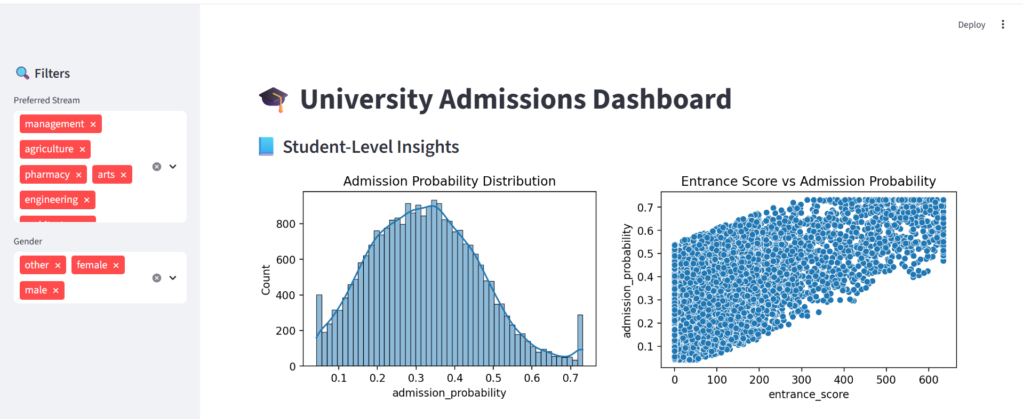

This screenshot shows a section of a University Admissions Dashboard focused on Student-Level Insights. Here's a breakdown of its key components and what they reveal:
🧭 Sidebar Filters
- Preferred Stream: Lets users select academic streams like management, agriculture, pharmacy, arts, engineering, etc.
- Gender: Filters data by gender categories — male, female, and other.
These filters allow users to customize the dataset being analyzed, tailoring insights to specific student groups.
📘 Visualization 1: Admission Probability Distribution
- Type: Histogram
- X-axis: Admission probability (ranging from 0.1 to 0.7)
- Y-axis: Count of students
- Shape: Roughly normal distribution with a peak around 0.35

Interpretation: Most students have admission probabilities clustered around 0.35, suggesting that the model predicts moderate chances for the majority.
📈 Visualization 2: Entrance Score vs Admission Probability
- Type: Scatter Plot
- X-axis: Entrance score (0 to 600)
- Y-axis: Admission probability (0 to 0.7)
- Trend: Positive correlation — higher entrance scores tend to result in higher admission probabilities.
Interpretation: Entrance score is a strong predictor of admission likelihood. Students with better scores are more likely to be admitted.
🔍 Overall Insights
- The dashboard helps users explore how student demographics and academic preferences influence admission outcomes.
- It provides data-driven transparency into the admissions process, which can be valuable for both applicants and institutions.

Dashboard part-2

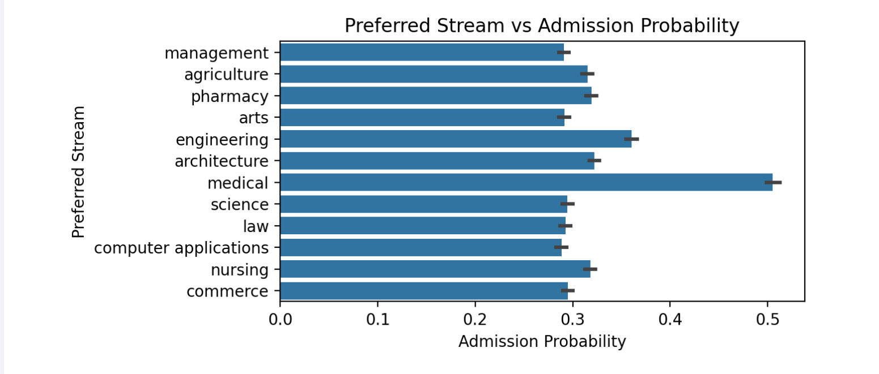

This horizontal bar chart titled "Preferred Stream vs Admission Probability" compares the likelihood of admission across various academic streams. Here's a detailed explanation:
📊 Graph Components
- X-axis (Admission Probability): Ranges from 0.0 to 0.5, showing how likely students are to be admitted into each stream.
- Y-axis (Preferred Stream): Lists academic disciplines such as:
  - Management
  - Agriculture
  - Pharmacy
  - Arts

• Engineering
  - Architecture
  - Medical
  - Science
  - Law
  - Computer Applications
  - Nursing
  - Commerce
- Bars: Each bar represents the average admission probability for that stream.
- Error Bars: Indicate variability or uncertainty in the estimates—wider bars suggest more variation among applicants.
- 🔍 Interpretation
- Medical Stream Leads: The medical stream has the highest admission probability, close to 0.5, suggesting strong applicant profiles or favorable admission criteria.
- Moderate Probabilities (~0.3–0.35): Streams like management, agriculture, pharmacy, and engineering fall into this range, indicating average competitiveness.
- Lower Probabilities: Streams such as arts, fashion, and commerce show slightly lower admission chances, possibly due to higher competition or fewer available seats.

📈 Insights
- Stream Selection Matters: Admission chances vary significantly by stream, which can guide students in making informed application decisions.
- Model Transparency: This visualization helps identify which academic paths are more accessible or competitive.
- Error Bars Add Depth: They show that even within a stream, individual admission probabilities can vary widely.

Dashboard part-3

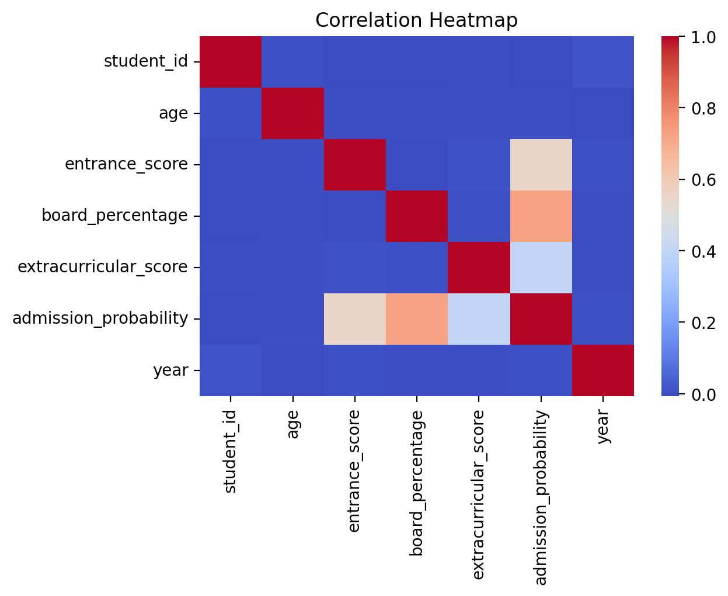

This Correlation Heatmap visualizes how different student-related variables are statistically related to each other. Here's a breakdown of what it shows and how to interpret it:
📊 Graph Components
- Variables Compared:
  - student_id
  - age
  - entrance_score
  - board_percentage
  - extracurricular_score
  - admission_probability
  - year
- Color Gradient:
- Blue: Low or negative correlation
- Red: High positive correlation
- Diagonal Line: Always shows perfect correlation (1.0) since each variable is perfectly correlated with itself
🔍 Key Observations
- Admission Probability:
  - Moderate positive correlation with:
    - entrance_score: Indicates that higher entrance scores tend to increase admission chances.
    - board_percentage: Suggests academic performance in school also contributes positively.
  - Lower correlation with extracurricular_score: These activities have a smaller impact on admission probability.
- Entrance Score vs Board Percentage: Likely shows some correlation, indicating students who perform well in school may also do well in entrance exams.
- Year and Age: May show weak correlation depending on how age is distributed across years.

📈 Insights
- Feature Selection: Helps identify which variables are most predictive of admission probability.
- Model Transparency: Reveals how different inputs influence outcomes.
- Data Quality Check: Can expose redundant or weakly related variables.

Dashboard part-4

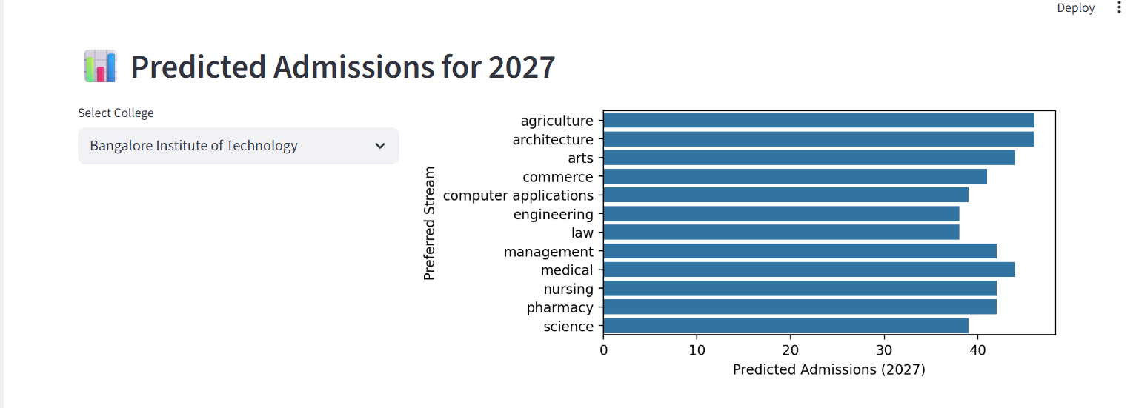
This dashboard titled "Predicted Admissions for 2027" provides a forward-looking view of expected student admissions at Bangalore Institute of Technology, broken down by academic stream. Here's a detailed explanation:
🧭 Interface Elements
- Dropdown Menu ("Select College"): Allows users to choose a specific college. In this case, Bangalore Institute of Technology is selected.
- Horizontal Bar Chart: Displays predicted admission counts for each academic stream in the year 2027.

📊 Chart Components
- X-axis (Predicted Admissions 2027): Shows the number of students expected to be admitted.
- Y-axis (Preferred Stream): Lists academic disciplines such as:
  - Agriculture
  - Architecture
  - Arts
  - Commerce
  - Computer Applications
  - Engineering
  - Law
  - Management
  - Medical
  - Nursing
  - Pharmacy
  - Science
- Bars: Each bar represents the predicted number of admissions for a stream. Most bars hover around or slightly above 40 admissions, suggesting relatively balanced intake across disciplines.
- 🔍 Interpretation
- Even Distribution: No stream dominates the chart, indicating a fairly uniform admission forecast across fields.
- Medical and Engineering: These typically competitive streams may show slightly higher bars, reflecting demand or institutional capacity.
- Planning Tool: This visualization helps administrators anticipate resource needs—faculty, facilities, and funding—based on projected student interest.
- 📈 Insights
- Strategic Forecasting: Useful for colleges to prepare for future enrollment trends.
- Student Guidance: Applicants can gauge which streams are expected to be more or less competitive.
- Model Output: These predictions likely come from a trained machine learning model using historical data.

Dashboard last part explaination
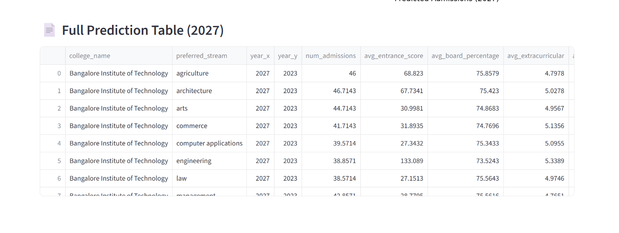

This table titled "Full Prediction Table (2027)" presents a detailed forecast of student admissions at Bangalore Institute of Technology across various academic streams.

🔍 Key Observations
- Highest Predicted Admissions:
  - Architecture (46.7) and Agriculture (46) lead in projected intake.
- Engineering: Despite being a popular stream, it shows slightly lower predicted admissions (38.9) but has the highest entrance score (133.1), indicating strong academic competition.
- Arts, Commerce, and Computer Applications: Have lower entrance scores (~27–32), but still maintain moderate admission numbers.
- Balanced Board Percentages: Most streams have average board scores around 74–76%, showing consistency across disciplines.
- Extracurricular Scores: Range from ~4.75 to ~5.34, suggesting moderate involvement across streams.
📈 Insights
- Stream-Specific Trends: Engineering attracts high-scoring students but admits fewer, possibly due to limited seats or stricter criteria.
- Data-Driven Planning: This table helps institutions allocate resources and anticipate student demand.
- Model Transparency: Shows how predictions are grounded in historical averages, making the forecast interpretable and actionable.

